AI ASSISTED CODING
NAME: K.Hemanth Kumar
HL-NO: 2303A52320
BATCH: 45
Lab 2: Exploring Additional AI Coding Tools beyond Copilot – Gemini (Collab) and Cursor AI
Lab Objectives:
- To explore and evaluate the functionality of Google Gemini for AI-assisted coding within Google Collab.
- To understand and use Cursor AI for code generation, explanation, and refactoring.
- To compare outputs and usability between Gemini, GitHub Copilot, and Cursor AI.
- To perform code optimization and documentation using AI tools.

Lab Outcomes (LOs):
After completing this lab, students will be able to:
- Generate Python code using Google Gemini in Google Colab.
- Analyze the effectiveness of code explanations and suggestions by Gemini.
- Set up and use Cursor AI for AI-powered coding assistance.
- Evaluate and refactor code using Cursor AI features.
- Compare AI tool behavior and code quality across different platforms.
Task 1: Refactoring Odd/Even Logic (List Version)
- Scenario:
You are improving legacy code.
- Task:
Write a program to calculate the sum of odd and even numbers in a list, then refactor it using AI.
- Expected Output:
- Original and improved code

Gemini AI:
#You are enhancing existing code to improve its quality and performance
Code:
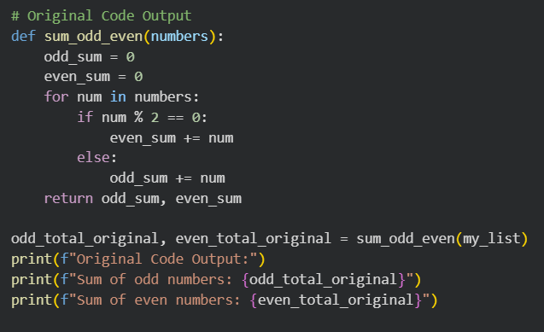
Output:
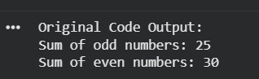

Cursor Ai:
#Implement a program to calculate sum of odd and even numbers in a list
Code:
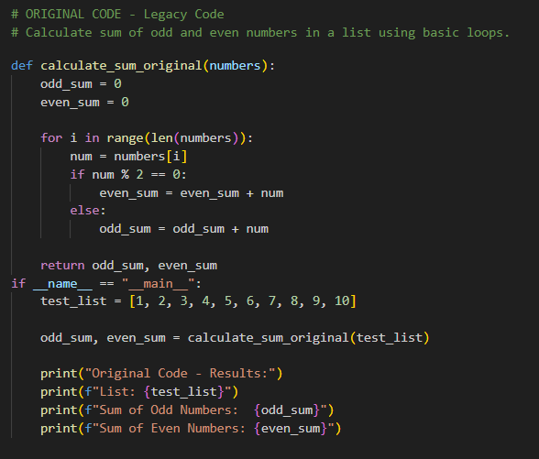
Output:

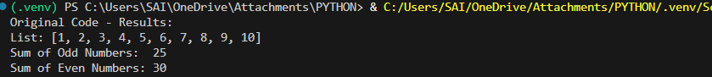
Task 2: Area Calculation Explanation
- Scenario:
You are onboarding a junior developer.
- Task:
Ask Gemini to explain a function that calculates the area of different shapes.
- Expected Output:
  - Code
  - Explanation
Gemini AI
Prompt:
#Implement a code which explains a function that calculates the area of different shapes
Code:
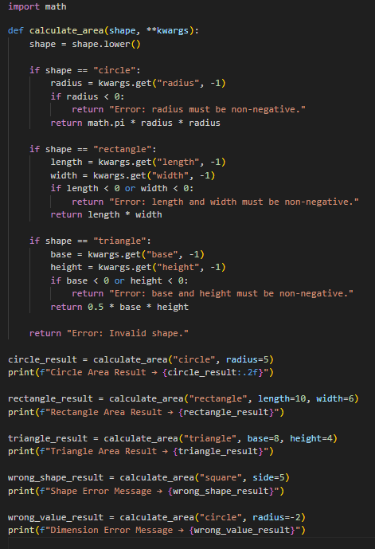
output:

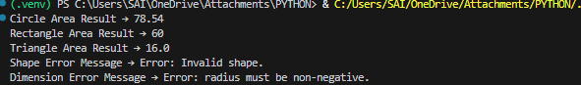
Explanation of the calculate_area function:
The Python function calculate_area is used to find the area of various geometric shapes by using the shape type and its required measurements.
Importing math module:
The math module is included so that the constant pi can be used while calculating the area of a circle.
Function structure (calculate_area(shape, **kwargs)):
The function accepts two inputs:
shape: A string that tells which shape’s area should be calculated, such as a circle, rectangle, or triangle.
**kwargs: A flexible parameter that allows passing different dimensions depending on the selected shape.
Decision-making logic:
The function applies conditional statements to identify the shape and perform the correct calculation:
Circle: The function extracts the radius, checks if it is valid, and then computes the area using the circle formula.
Rectangle: It collects the length and width values, verifies them, and calculates the area by multiplying them.
Triangle: It takes the base and height, validates the inputs, and finds the area using half the product of base and height.
Error handling:
If an unknown shape is given or if the provided dimensions are incorrect or missing, the function responds with a clear error message.
Output:
The function returns either the calculated area as a numeric value or an error message if the input is invalid..

Task 3: Prompt Sensitivity Experiment
- Scenario:
You are testing how AI responds to different prompts.

- Task:
Use Cursor AI with different prompts for the same problem and observe code changes.
- Expected Output:
  - Prompt list
  - Code variations
Prompt list:
#Implement a code to find largest element in an array
# Implement a optimized code to find largest element in an array
# Implement a code to find largest element in an array using built in function
# Implement a code to find largest element in an array without built in functions
# Implement a code to find largest element in an array and also handle the empty lists
Code variations:
comparison of the approaches we covered:
- Language / snippet: Python for all.
- Goal: Find the largest element in an array (list).
- Complexity: All are O(n) time, O(1) extra space unless using built-ins (still O(1) extra space in practice).
Approach | Uses built-ins? | Handles empty list? | Code sketch | Pros | Cons
Single pass, manual | No | Yes (raises error) | largest = nums[0]; for v in nums[1:]: if v > largest: largest = v | Simple, explicit control, O(n)/O(1) | Slightly more code than built-in
Single pass, manual (without empty guard) | No | No (would error on empty) | same loop, but no empty check | Shortest manual loop | Must ensure non-empty input elsewhere
Built-in max(nums) | Yes (max) | Yes (with explicit check) | if not nums: raise ValueError(...); return max(nums) | Most concise, well-tested | Still O(n); requires import? (no)
Built-in max(nums) without guard | Yes | No (ValueError on empty) | return max(nums) | One-liner | Crashes on empty unless caller guards
Notes:
- All approaches are optimal for this task; the difference is mainly brevity vs. explicit control.
- For production, prefer either the guarded manual loop or max with an explicit empty check.

Task 4: Tool Comparison Reflection
- Scenario:
You must recommend an AI coding tool.

- Task:
Based on your work in this topic, compare Gemini, Copilot, and Cursor AI for usability and code quality.

- Expected Output:
Short written reflection
Note: Report should be submitted as a word document for all tasks in a single document with prompts, comments & code explanation, and output and if required, screenshots.
Code:
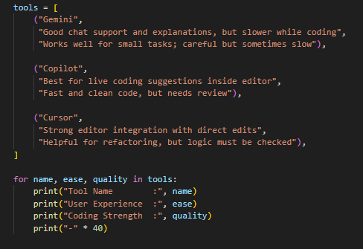
Output:
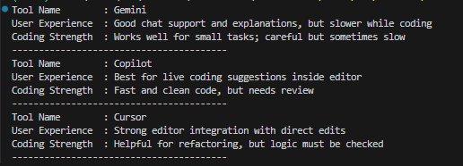
Short reflection
• Gemini: Very helpful for understanding problems and getting guided explanations, though it’s not as smooth for making quick inline code changes.
• Copilot: Excellent for fast code suggestions while you’re actively coding, but its output should always be reviewed to avoid mistakes.
• Cursor AI: Effective for making direct edits and refactoring across files, and works best when given clear instructions and careful verification.

